FAIR TRADE TOWNS HANDBOOK

Fair Tr

Fairtrade is about putting people at the centre of trade, and acknowledging and valuing the work that has gone into producing anything we consume. A Fairtrade Town makes Fairtrade values a part of the community’s life, makes it accessible, and sends a message on how trade will work in the future.

Table of content
ade

- Introduction 4
- What is Fair Trade Town? 5
- How to read this manual 8
- The way forward 9
- The five goals 10
- Goal one: Gaining council support 11
- Goal two: Create a local steering committee 13
- Goal three: Getting media coverage for outreach 16
- Goal four: Making Fairtrade a part of the community 18
- Goal five: Bringing Fairtrade to consumers 20
- Goal six: Inform the community 22
- Goal seven: Developoing Fairtrade practices in local production 26
- Adding your own goals 28
- Applications & Renewals 30

Introduction

Fairtrade is a global movement that aims to empower the farmers and workers in our food and fashion supply chains. It is a trading partnership, based on dialogue, transparency, and respect, that seeks greater equity in trade. Highlighting the need for change in the rules and practices of conventional trade, it shows how a successful business can put people first and seeks to alleviate poverty in ways that improve lives, strengthen communities, and protect the environment. It brings the consumer and producer together, and gives people the opportunity to make a difference to their farmers through their everyday choices. A fairer choice of a cup of tea can empower a tea plantation worker and adding Fairtrade certified fashion to your wardrobe can ensure that the cotton farmer receives a fair price for his work.

This guide is for anyone interested in making Fairtrade a part of their community. With your motivation and a few simple steps, you can achieve Fairtrade Town status which will unite existing supporters and activity, as well as encourage more people to be a part of the movement!

The strength of Fairtrade Towns is that they involve the whole community. They bring people together and increase understanding of how small actions add up to make a big difference to the lives of people thousands of miles away.
”
“

Bruce Crowther, Chair, Garstang Fairtrade Town

What is a Fair Trade Town?

The core principle of the Fair Trade towns movement is a commitment to community development. This initiative is backed by consumers, businesses, educational institutions, local grocery stores, cafés. and restaurants to engage actively in supporting producers, raising awareness, and campaigning for changes in the rules and practices of conventional trade. It is a collective movement of the people to bring social equality and environmental sustainability.

Fairtrade is about putting people at the centre of trade, and acknowledging and valuing the work that has gone into producing anything we consume. A Fairtrade Town makes Fairtrade values a part of the community’s life, makes it accessible, and sends a message on how trade will work in the future. In India, this will mean giving local farmers and artisans access to fairer and more ethical trade, where we already see an increase in farmer suicides as well as, countless sweatshops across the country.

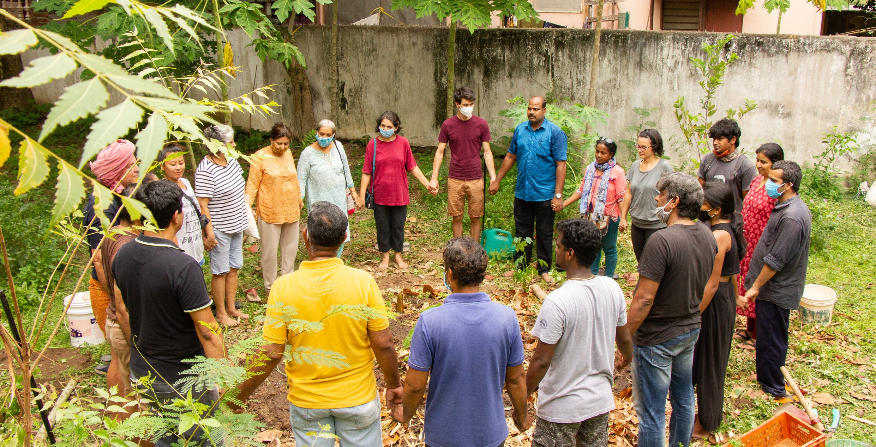

A Fairtrade Town is any community that:

Supports Fairtrade and deepens understanding of the benefits Fairtrade
brings.

Takes action by choosing Fairtrade products whenever possible and encourages others to do likewise.

Achieves and continues to take action on the five Fairtrade Town goals set by
the Fairtrade Foundation.

Inspires, learns, and collects best practices to use for both established and emerging Fairtrade Town campaigns in order to build a strong national campaign thereby, empowering and assisting campaigns in other Towns in order to promote awareness of Fairtrade.

Encourages campaigns to adopt an inclusive model for Fairtrade Towns and promote better understanding of the ‘Big Tent’ approach.

Builds a movement of national Fairtrade Town campaigns that supports policies for Fairtrade, and trade justice in particular, by the development of ethical public procurement, as well as advocacy for Fairtrade.

Did you know?

The Fair Trade Town movement was first launched in 2001 in Garstang, Lancashire, under the initiative of Bruce Crowther, a local Oxfam supporter, and the Garstang Oxfam Group.

Today we have reached

- 39 Countries, 6 Continents
- 2022 FT Towns, 14 Capital cities
- 2 Fair Trade Nations
- Almost 2000 FT schools
- At least 500 Universities
- 1000 FT works space and Faith Communities

How to read this Manual

This handbook covers the five go- als of a Fairtrade Town in an easy explanation along with tips and suggestions to make the process simpler. The process is set out in steps: how to start, activities and possible actions that can be taken, and finally how to maintain the momentum once the goal has taken root. Each goal has require- ments to fulfill it, as well as other resources that you could use.
With each step be creative, and try to see what fits best with your community. You won’t know what works unless you give it a shot, and keep learning through your experience. It’s important to re- member you miss 100% of the shots you don’t take! You can also add your own goals, based on the culture in your community, or any other factors that you feel are im- portant to highlight. Finally, once

Things to look out for

The magnifying glass: this symbol is for added resources you can read, or short video clips that can help bet- ter understand or help you ideate.
The hammer: a tool that other Fairtra- de Towns use that could be helpful in your own journey and that you could incorporate by slightly modifying or using just as.
The loudspeaker: an interesting and pertinent quote to motivate you and give you some insight on personal experiences.

The question mark: the “did you know” section that gives you small quirky bits of information that might not necessarily help, but are inte- resting facts that are fun to know!
The exclamation mark: an idea or a suggestion.

The way forward

The Big Tent

In India, the “Big Tent” approach has been implemented- it is an inclusive model that works to promote and drive sales of a wide range of Fairtrade products. This approach supports and promotes all stakeholders at the local and national level. A National Steering Committee (NSC) has been put in place that will represent the grassroot movements (Fairtrade Towns) while playing a governing role to ensure the integrity of the overall framework, and making sure these towns’ views are reflected across India. One specific area where the NSC holds governance is with regards to what certifications or organizations count as officially Fairtrade, for the purposes of the criteria over and above Fairtrade International and WFTO.

In addition to systems, the NSC contributes to the development of the strategic planning and direction of the Towns campaign in the country, nominates and selects new NSC members, assists in the delivery of strategic goals and directives, provides regional and network support to Town campaigns across the country and works closely with staff to grow and strengthen the campaign nationally.

Non-certified and other Fairtrade initiatives, including Fairtrade shops are nonetheless important actors in the Fairtrade Towns networks. They are frequently involved at the local level in the activities of campaign groups and recognized as an important part of the campaigning narrative for Fairtrade Towns, although non-Fair Trade certified products are not a requirement within the goals for Fairtrade Towns.

The five goals
As mentioned earlier while defining a Fairtrade Town, five goals out of seven must be met for any place in India to become and uphold being a Fairtrade Town. There are three mandatory criteria that all towns need to fulfill and 2 additional crite- ria which can be selected based on the local context. The goals are designed to ensure as many people as possible can get involved and a Fairtrade Town ne- eds everyone to play their part – from the local authority to cafés, businesses to schools, local newspapers to community groups. A vibrant Fairtrade Town brings together a cross-section of the community, united in their support for Fairtrade and for farmers and workers in developing countries. The steering group encou- rages, monitors and coordinates action by local organisations, groups and busi- nesses.

  - Local council passes a resolution supporting Fairtrade, and agrees to serve Fairtrade products (for example, in meetings, offices and canteens) through its activities and budgets. (MANDATORY)

  - A local Fairtrade steering group is convened to ensure the Fairtrade Town cam- paign continues to develop and gain new support. (MANDATORY)

  - Media coverage and events raise awareness and understanding of Fairtrade across the community. (MANDATORY)

  - Local workplaces and community organisations (places of worship, schools, universities, colleges and other community organisations) support Fairtrade and use Fairtrade products whenever possible.

  - A range of (at least two) Fairtrade products are readily available in the area’s retail outlets (shops, supermarkets, newsagents, petrol stations) and served in local catering outlets (cafés, restaurants, pubs).

  - Every year, at least one event is organized to promote and inform the commu- nity about Fairtrade. This event must involve at least 10% of the population in the Town.

  - At least 50% of the crafts and agricultural production in the community should
be Fairtrade and/or follow Fairtrade principles.

When the community has reached at least five of the above criteria, the local steering committee will conduct a self-assessment and, after gathering all the information necessary, submit all the evidence to the NSC. They will review the information given, as well as the community, and if everything adds up they will the town a Fairtrade Town.

Once the recognition is achieved, celebrate with all the stakeholders and supporters and communicate the success with the community! Organize an announcement ceremony, instal city signposts and have the media talk about it. Every idea to spread the word that the community is Fairtrade is a good idea!

Goal one - Gainning council support

Goal One: Local council passes a resolution supporting Fairtrade, and agrees to serve Fairtrade products (for example, in meetings, offices and canteens) through its activities and budgets.

At the onset, the local council can help back the Fairtrade Towns movement, and give it much needed support. Therefore, the resolution being passed is a very important step in consolidating the Town’s status as a Fairtrade Town. There are a few more requirements to the goal, for example:
The resolution must include a statement of support for Fairtrade, as well as a commitment to use Fairtrade products whenever possible in meetings, or in their offices etc.

The council should take practical action on the resolution and introduce and encourage Fairtrade to other branches it is involved in.

There must be a named council representative on the Fairtrade steering committee.

The local council can also:

Promote Fairtrade through social media and other publications.

Create awareness of Fairtrade among staff and associates through events, cam- paigns or even posters and flyers around the workplace.

Extend the range of Fairtrade products used.

Support the steering committee through funding, or providing access to spaces for meetings or events.

Work with other public bodies (schools, hospitals, police) to encourage and raise awareness about Fairtrade.

Create signs and boards in public areas to raise awareness about Fairtrade, or the Fairtrade Town status.

On August 14th 2017, the Twin Towns Steering Committee signed and handed out the Resolution letter to the Gover- nor of Puducherry, Dr. Kiran Bedi, and the Chief Minister of Puducherry, Mr. V. Narayanasamy. Another landmark in the history of the Fairtrade Twin Towns.

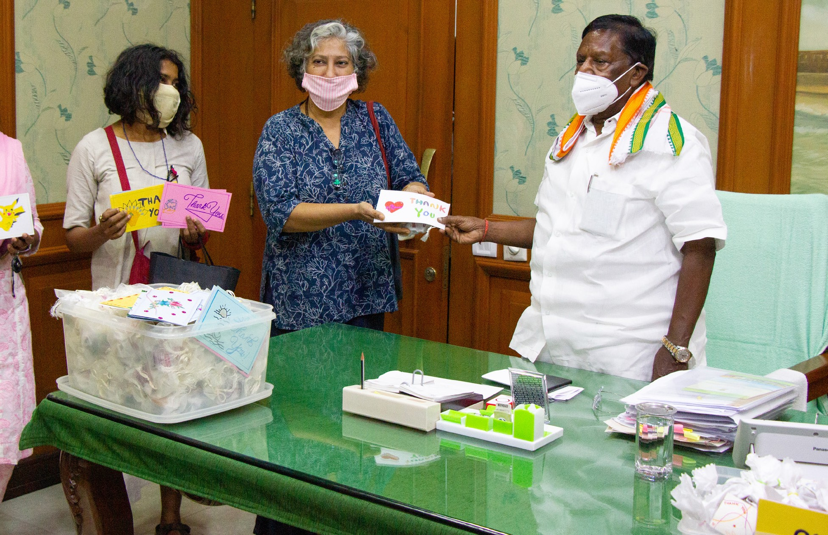
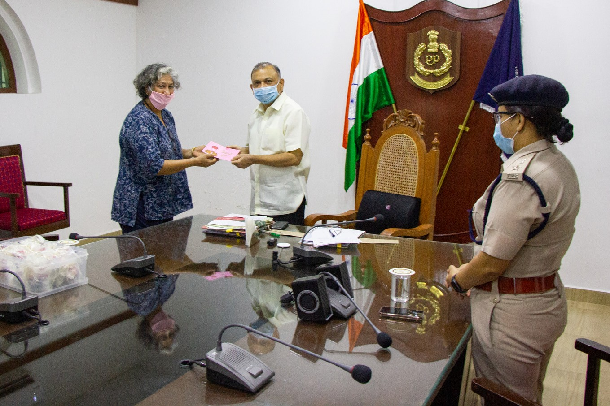
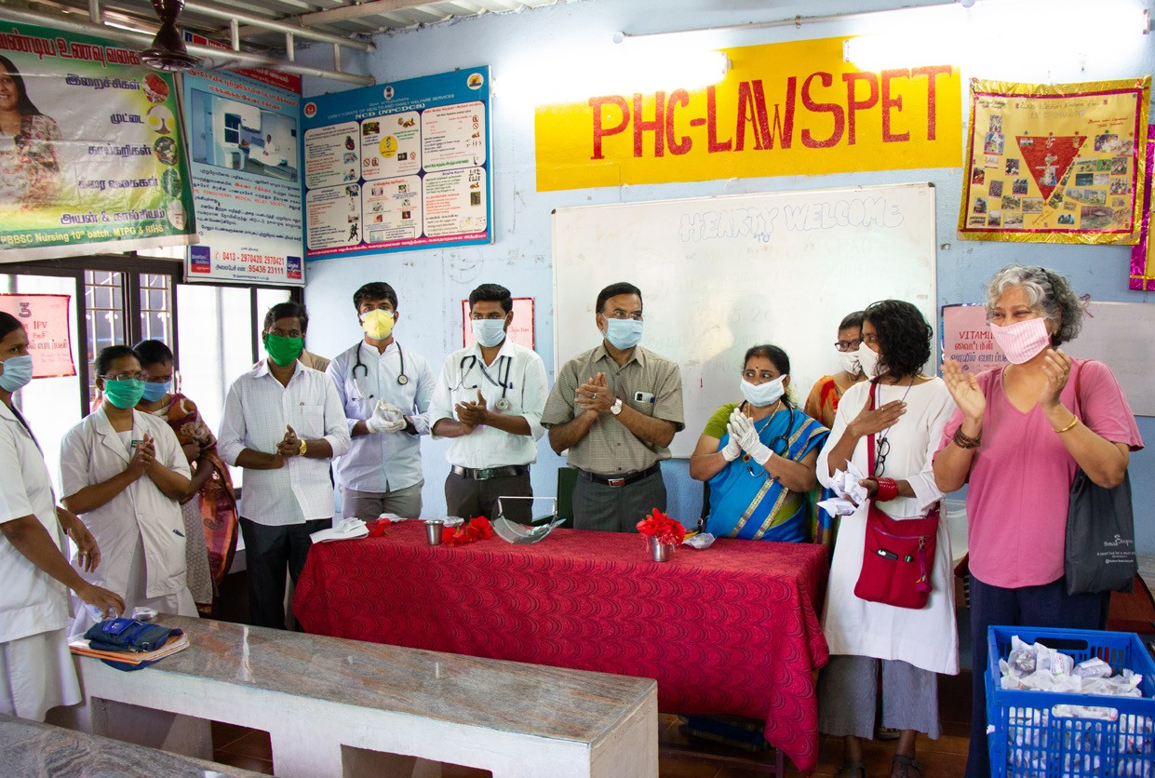

To get started, there are a few things you can do to keep up the engagement with the local council. For example, asking them to show public support plays a large role. This can be achieved through developing a Fairtrade policy which will put Fairtrade on the map. This is most effective if you have identified and then worked with individuals or departments most willing and enthusiastic about Fair- trade within the council. These should ideally also be officers and people who are supporters of development and sustainability, as well as any other causes that align with the Fairtrade aims. Involving them in Fairtrade events is a good way to inform them further on what Fairtrade is and could allow them to add it to their own rhetoric.

It is important that you work closely with the council to maintain momentum, while also making sure they benefit from being involved with the local Fairtrade campaign. Furthermore, linking Fairtrade to current events and local issues, for example the “Make in India” campaign, helps both petitions, and can put Fairtra- de on the map, while simultaneously supporting local businesses and promoting local produce. This can raise awareness of the challenges faced by our small sca- le farmers and stresses the shared need for a fair price.
“

A people’s movement such as this must be led by the people. Individuals, communities, and businesses are the same thing, and that’s what makes the concept of a Fair Trade Town so fantastic, because it covers everything. Movements don’t need a strategy; people are doing it because they follow their hearts and their passion. If people want to focus on a particular issue and do something about it, such as supporting Black Lives Matter, then they should do it. [...] Those that
support Fair Trade will naturally support the Black Lives Matter movement because they share common aims, to eradicate global inequality and injustice.
”

- Bruce Crowther, Chair, Garstang Fairtrade Town

Involving local authorities in events is a good way to bring visibility to the move- ment. Here’s an idea for you:

The Fairtrade Twin Towns initiated an “Act of Kindness” campaign in April 2020 to spread some joy and recognize the efforts of the frontline workers who have been working day and night to keep us safe in these unprecedented times. The Fairtrade Gratitude Cakes were baked with Pascati Cocoa as the key ingredient, a Fairtrade India certified cocoa that is sustainably grown by farmers from Kerala. The cakes reached doctors and nur- ses at 8 primary health centers and hospitals, 2 municipalities, the workers at Swachh Bharat and the policemen of the town. Gratitude was expressed by the government of- ficials who have been touched by this gesture of the citizens, including the honourable Chief Minister V. Narayanswamy, honourable Lt. Governor Dr. Kiran Bedi, and DGP Balaji Srivastava, Chief Secretary.

Goal two - Create a local steering committee

To ensure the Fairtrade Town continues to develop and gain new support, a local Fairtrade steering committee must be convened. It is formed of various stake- holders from civic society, NGOs, businesses etc. Once the community is formally recognized as a Fairtrade Town, a 3/5 year roadmap to development must be im- plemented to ensure continuous progress. The group must meet regularly and re- present a range of local organisations and sectors. It will also predominantly lead Fairtrade Town towards the goals, submit the application for the area, as well as all applications to renew Fairtrade status thereafter. The group is responsible for en- suring that events are organised regularly, but specifically during Fairtrade Week.

Some other points of action the group may take are:

- Prepare action plans for the future.
- Set indicators to monitor progress and celebrate successes with the wider pu- blic.
- Form smaller working groups to focus on specific activities and targets, for
example events or work with schools.
- Continue to recruit and welcome new members.
- Maintain and update a volunteer list of supportive individuals and organisa- tions.
- Open a bank account to manage donations and income from fundraising acti- vities.
- Keep up to date with the latest news on Fairtrade by subscribing to the Fairtra- de Town and Campaign e-newsletters published by the Fairtrade Foundation, and following the Fairtrade Twin Town movement on social media for ideas.

The steering group is the heart of a thriving Fairtrade Town. Working towards and achieving the five Fairtrade Town goals is a significant achievement, not an end in itself! Fairtrade already has a real impact on the lives of over seven million people
– farmers, workers and their families – but remains an alternative to conventional trade that needs to grow.

STEERING COMMITTEE PHOTO

The steering group is the heart of a thriving Fairtrade Town. Working towards and achieving the five Fairtrade Town goals is a significant achievement, not an end in itself! Fairtrade already has a real impact on the lives of over seven million people
– farmers, workers and their families – but remains an alternative to conventional trade that needs to grow.

The steering group works to keep up the pressure and make Fairtrade the norm by:

  - Increasing support and involvement: Developing action on the five goals will involve new groups, organisations and businesses and provide opportunities for existing supporters to take further action.
  - Deepening public understanding: Ongoing work by the steering group will make the general public understand the role Fairtrade plays in a more sustainable fu- ture.
  - Setting targets and monitoring progress: The steering group steers activity. Clear targets and objectives in addition to new ambitions and activities will en- sure the Fairtrade Town stays on course and goes from strength to strength.

It’s vital that you find committed and enthusiastic people to be involved with the movement, whether they be a part of the committee or even volunteers. Reach out to people who could be interested starting from inner circles such as family and friends and then perhaps move further away. Advertising for specific skills requi- red is also a good way to engage with people from universities or friends of friends. The main idea is to keep yourselves open to anyone who may want to participate- the more the merrier!

Things to do to be more efficient and mindful:

- Meet frequently and regularly, and make sure the meeting ti- mings and venues are convenient to everyone. Local cafes and restaurants that serve Fairtrade tea or coffee are great venues!
- Be organised. Always send an agenda ahead of time for pe- ople to be prepared. Taking minutes and then sharing them with the group helps keep everyone up to date, or even helps refresh everyone’s memories on key takeaways.
- Keep meetings focused and productive. Stick to your ti- melines, be clear on the objective of the meeting and keep everyone in the loop on outcomes and resolutions.
- Guest speakers are a good way to keep things fresh and new.
- Try to keep things fun! Cook together or just bring snacks to celebrate the group!
- Don’t get bogged down. Meaningful and effective campaig- ns take time. You cannot solve the world’s problems over a cup of coffee, but you could come up with the idea that could create a sustainable change in the long run!

The most important task of the steering committee is having an action plan. It helps maintain direction, highlights challenges and achievements and keeps energy and motivation high. Objectives for your Fairtrade Town based on what you have achieved so far and priorities for the future are always useful. You may find it helpful to have a general action plan for the overall campaign and separate plans for specific activities such as events or working with schools. Defined actions are an easy way to achieve targets.

Goal three - Getting media coverage for outreach
A good way to get Fairtrade recognized, understood, and widely supported is through media coverage and events. Use local newspapers, social media, and te- levision to take Fairtrade to the wider public, and make Fairtrade a common term amongst the community. Regular articles and social media posts about relevant and current issues will help you engage audiences that you might otherwise miss. It’s also a great platform to inform people, and creating events is a good way to entertain and recruit new volunteers.

Fundamentally, local media often dictates what is in and what isn’t. Putting Fair- trade on the agenda through regular articles and media updates will encourage more groups, organisations and individuals to get involved and develop your Fair- trade Town campaign.

Here’s some things you can do to get started:

- Do your research! Find out which local media is the easiest and most accessible to tap into.
- Find out which journalists work on community events, or sustaina- bility and reach out to them. Work on building a lasting relationship with them, while also keeping in mind that journalists can move on quickly. Be ready to offer some Fairtrade chocolate or coffee sam- ples in addition to a great, long-running local story.
- The campaign to achieve and maintain Fairtrade status is a story in itself. Launch the campaign with a public event – a Fairtrade break- fast in the Town Hall or a public meeting for example – and invite the press contacts you’ve identified. Keep the press updated as each goal is achieved and when significant victories are won.
- Be polite and professional when approaching the media and never call on deadline day!
- Participate in existing community events around town- for example school fests or literature fests with a Fairtrade stall to reach more people.
- Most newspapers and magazines prefer having a spokesperson to comment on the story, so remember to pick someone from your ste- ering committee who will make a good candidate- an MP or a well-k- nown and approachable person in the community.

As you can tell, the reason for working with the media is to have widespread mes- saging. But what is crucial is also what kind of messaging, and more importantly what exactly the message will be. To effectively catch people’s attention and want them to spend time learning and informing themselves it is vital that the rhetoric is crisp, and to the point, while also being engaging and informative. It is a waste of time to get too bogged down by details. While there are a million different stories you can tell about the difference Fairtrade makes or ways everyone can get invol- ved, there are three useful messages that can help keep things simple, structured and effective:

Why is Fairtrade important?

Fairtrade makes trade fair. A lot of world trade is keeping people trapped in pover- ty. Two billion people – one third of all humanity – work incredibly hard for a living, but still earn less than INR 150 per day. Farmers are often forced to sell below what it cost them to produce their crop and struggle to feed their families, let alone in- vest in their future. Fairtrade is about trying to change that.

How does Fairtrade make trade fairer?
Fairtrade ensures that farmers and workers around the world earn enough for to- day and a better life for tomorrow. As well as the price they get paid for their crops, the Fairtrade system is unique in providing an additional amount of money (the Fairtrade premium) for the farmers and workers to invest jointly in projects of their own – such as health clinics, improving schools, clean water, improving their pro- cessing facilities, providing training, repairing roads or building community cen- tres.

Why are you telling me?
You can make it happen! Fairtrade has grown from three Fairtrade certified pro- ducts in 1994 to over 4,000 by 2008. This happened because ordinary people went into their shops and asked for Fairtrade products. However, millions of farmers still remain trapped in poverty by trade, and it’s only if more of us choose Fairtrade products more regularly that Fairtrade will be able to reach them. Each individual action adds up to a world of difference – be a part of it.

If you only want to buy cheap products, farmers will also resort to cheaper practices. That’s where Fairtrade comes into play. It is about putting an end to the exploitation
“
of labour, and restoring the respect in the producer- consumer relationship.
”

- Abhishek Jani, CEO of Fairtrade India

Goal four - Making Fairtrade a part of the community
One crucial step to the movement is that local workplaces and community orga- nisations (places of worship, schools, universities, colleges and other community organisations) support Fairtrade and use Fairtrade products whenever possible. The general target for this goal is to achieve at least one institution sourcing Fair- trade products every 10,000 people. During the proposal, the NSC expects credi- ble progress in the first year, with a 3 year plan to achieve these targets.

Local workplaces that cannot support the campaign by selling Fairtrade products can get involved by making Fairtrade products available to their staff and clients. Even places of worship, which are on almost every street of an Indian town could use Fairtrade products when offering refreshments to people. Schools and uni- versities have ample spaces that can offer Fairtrade products- for example, can- teens and staff rooms, at any event that is held the t-shirts can be Fairtrade cot- ton, and footballs can be Fairtrade. Very simply,looking around your community you will find numerous spaces that can offer Fairtrade products- they just need to be nudged.

Action taken by the community makes a large difference. Fairtrade is a way we can all contribute to positive change. Workplaces can make Fairtrade available to staff and clients, school pupils can learn about the problems of unfair trade and how Fairtrade helps to tackle them. More groups and organisations using Fairtrade products means more farmers and workers have an opportunity to earn enough for today and to invest in a better tomorrow by selling on Fairtrade terms.
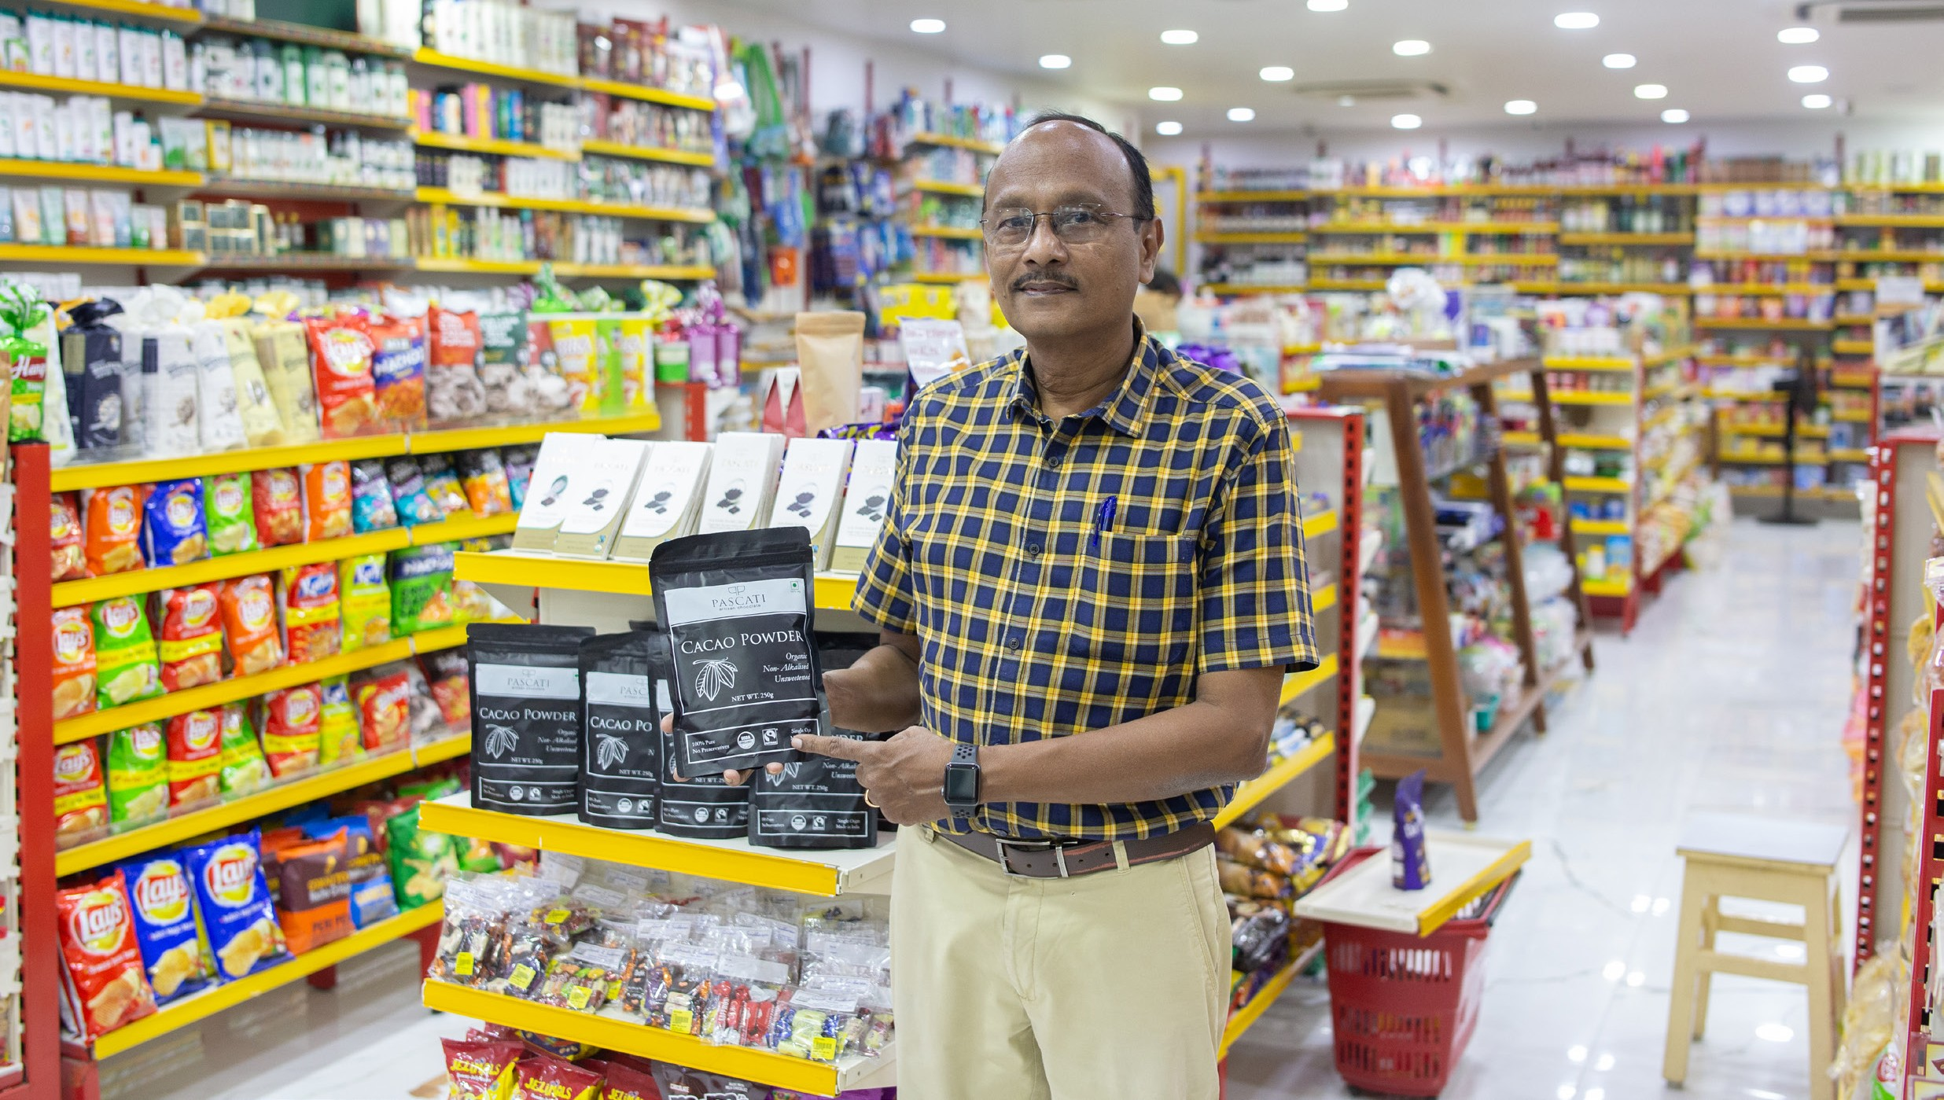

Getting a foot in the door of a business, place of wor- ship, school or society is easiest for someone who is already involved with the organisation. It may be use- ful to put together an information pack for friends and supporters to take to their workplace or child’s school. A good pack could include:

- Information about Fairtrade and the local Fairtrade Town campaign.
- A petition that can be easily adapted for any organi- sation and signed by staff, pupils or members to de- monstrate internal demand for Fairtrade.
- Information about local suppliers offering Fairtrade
products to enable change to happen.
- Examples of local businesses, schools and organisa- tions that have already made the switch to inspire and encourage others. Peer pressure can be a great tool!
- A pledge form to record future commitments.

Following on, create opportunities for groups and organisations to hear about Fairtrade by inviting them to events. Try and combine informative films or presentations with fun opportunities to try Fairtrade products, chat informally about Fairtrade and share ideas for local action. If they won’t come to you – can you go to them? Many Fairtrade Towns have found offering to do a presentation or assembly is a good way to reach people. Be proactive- go over to schools, or events and offer activities or a quick introductory presentation. You miss all the shots you never try!

Once you have a community with local groups that have pledged to switch to Fairtrade,support them. Publicise them in Fairtrade directories or give them a shout out on social media. It is important they know that you value their support and their shift. It also makes them feel good about their actions! This will also help in the hardest part of this goal- maintaining a momentum. How can you get people to continually pledge support and also build from there?

Did you know?

Vidyashilp Academy became the first Fairtrade school in India in 2018. Starting with the school uniforms which are made from organic cotton and produced in Gujarat, even the green tea served across the school premises is Fairtrade-certified. The school also made its social commitment even more pronounced by serving fully Fairtrade meals to its students and staff. All the condiments meet Fairtrade standards.

Goal five - Bringing Fairtrade to consumers
It should be easy for consumers to access Fairtrade products, and one of the ways in which to do that is to make sure stores and cafes have Fairtrade products ea- sily available. That way whenever they eat out or go grocery shopping they can increase consumption of the products, and increase the demand and need for more Fairtrade products to be made available. If it is not possible for people to buy these, it is difficult to allow people to get behind the movement.

Encourage local shop and cafe owners to sell and serve Fairtrade, especially new businesses or businesses that already have a sustainable or ethical approach in their sales. Slowly move them to increase the range and variety that they offer, and to also make these products and their support more visible with posters or fliers. Involve them in the local campaign- encourage them to host events and activities in support, and also give them visibility on your social media or in any events you may organize.

Fairtrade is an alternative way to trade that works with the normal rules of supply and demand. The difference is that the aim is to make trade work for development. Buying Fairtrade is one way we can all do something towards tackling poverty
– but only if products are available for us to buy.Fairtrade needs to become the norm and this is where Fairtrade Towns can make all the difference by working with retail and catering outlets to:

Make Fairtrade widely available
Successful action on the other Fairtrade Town goals will increase demand for Fair- trade products in your area. Local shops, supermarkets, cafés, pubs, restaurants, petrol stations and corner shops need to offer Fairtrade products and meet that demand.

Make Fairtrade visible in your area
Supportive stores and cafés can promote Fairtrade with posters, point of sale ma- terial and window stickers. Studies show that shoppers only spend three seconds selecting which jar of coffee or bag of rice to buy. Three seconds is enough time to make a difference if people remember to choose Fairtrade!

Showcase the range of Fairtrade products available
Give customers a real flavour of all Fairtrade has to offer. Thousands of different products have been licensed to carry the Fairtrade Mark – from spices to con- diments, cotton to coffee, chikki to footballs. Shops and cafés play a real part in letting people know what Fairtrade options are out there.

Figure out what Fairtrade products are available around your area already, and try to see if more stores or cafes can stock them. Perhaps make a local directory of what Fairtrade products can be purchased where- be it Fairtrade vodka at your fa- vourite pub, or Fairtrade chikki at your local supermarket for your kids. More often than not people just aren’t aware of their options and go for the most well-known options. Bring Fairtrade products to the foreground by putting them in the limeli- ght, informing people that they are readily available in spaces around them. When it comes to chocolate and coffee, people do experiment and try new flavours to find what suits them best, so don’t miss out on the opportunity to let them know their midnight cravings can be ethical, sustainable, and delicious!

Working with commercial partners Do’s:
- bring stores and cafés on board by demonstrating demand exists for Fairtrade products, by conducting studies or polls- anything to gauge interest and to show proof.
- provide opportunities for staff and managers to le- arn more about Fairtrade and help them understand why their customers choose Fairtrade. Don’t forget even staff are consumers and asking them to make a shift could lead to them making suggestions at the workplace too.
- build lasting relationships and make supportive stores and cafés feel part of the local Fairtrade campaign.

Don’t:
- give the impression that the company is being endor- sed – only their actions promoting Fairtrade products.
- allow one company to monopolise the campaign – this may discourage others from getting involved.

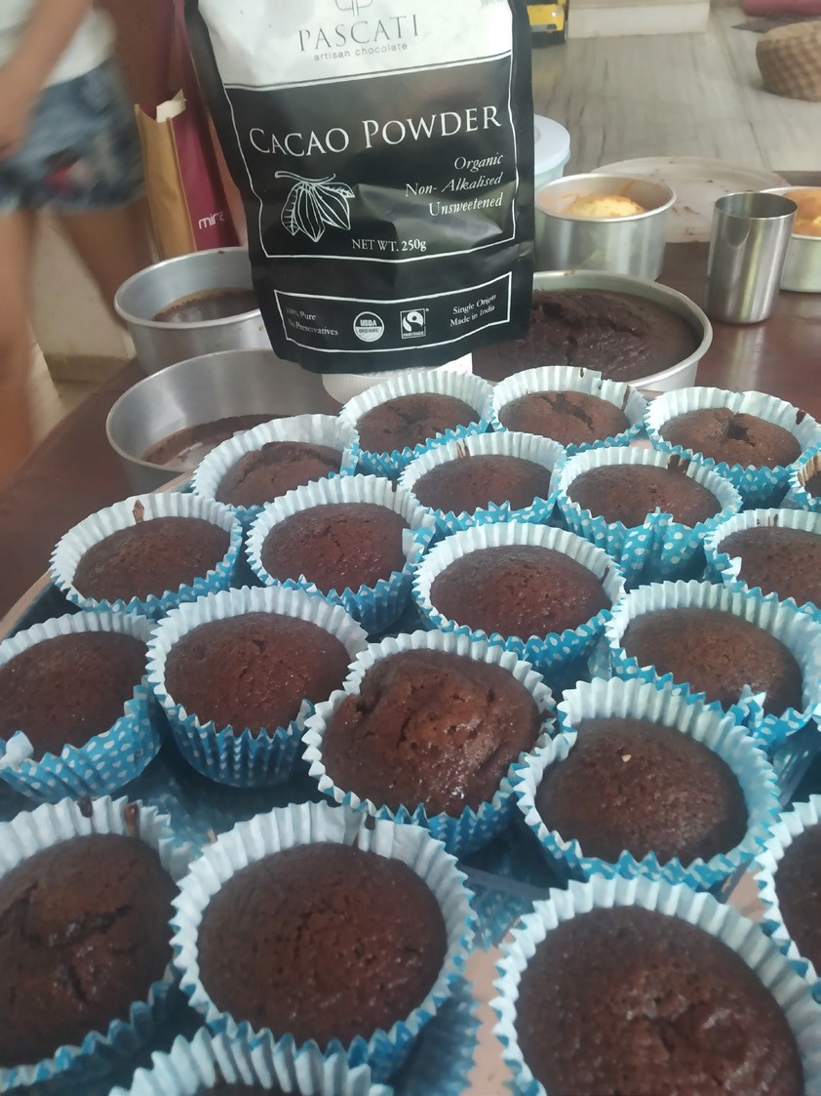

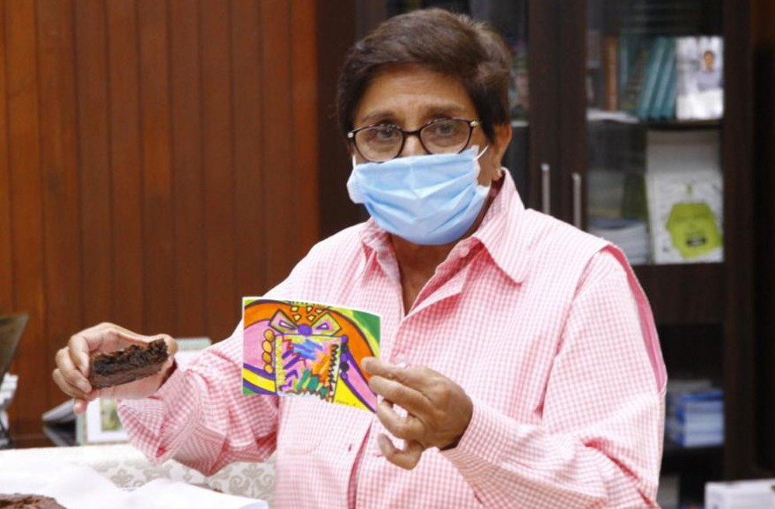Did you know?
In the Fairtrade Twin Towns, Gratitude Cakes event, the cocoa used was Pascati Cocoa, the key ingredient, a Fairtrade India certified cocoa that is sustainably grown by farmers from Kerala and is available in Grinde, a popular store in Puducherry that has stocked many Fairtrade products on their shelves. When the cocoa and chocolates came to Grinde, there were multiple social media posts by the Twin Towns account, as well as Grinde’s social media account, garnering further visibility. Devansh Ashar, founder of Pascati chocolate, discovered that the Indian cacao farmers were being exploited, and decided to go organic to Fairtrade. “Parity in the supply chain is important,’’ he said.

Goal six - Inform the community
A large way in which Fairtrade across the world has reached out to communities and the general public is through events and campaigns. These tend to create a wave of learning that can be short lived but with lasting effects if done correctly. It is important therefore that every year, at least one event is organized to promote and inform the community about Fairtrade. This event must involve at least 10% of the population in the town to effectively capture the audience’s attention, as well as work with the old adage “there is strength in numbers”.

Campaigns and events bring visibility to Fairtrade, since most of the population does not even know what it means or represents. Giving them an idea and defini- tion of what choices they have at their disposal is crucial to aiding the movement. Also creating something viral makes more people want to jump onto the bandwa- gon, because staying up to date and being a part of fun trends and challenges is a current phenomenon.

28

Events or campaigns must be easy- most people will not participate in something that takes too much time or isn’t fun. Engagement is at its highest when you com- bine these two aspects. Put yourself in the other person’s shoes and see what would excite and motivate you to get out of bed and take a photo or a small video which will help you gauge how best to capture your audience’s attention.

A few key pointers on how to most effectively work towards your goal (with Sudeep Srivastava, Management Consultant, Facilita- tor):

  - What is an event? And therefore what is not an event?
An event can be deemed to be any activity that engages the target audience in its planning, execution and has take-aways that last well beyond the duration of the event. Take-aways would typically be on the lines of Awareness Creation, Inclusion, Demonstration, Society-Buil- ding, etc. Therefore, an activity that merely displays the Fairtrade name or advertises it, or displays some information, shall not be construed to be an Event under this head. This is a community activity facilitated by the Fairtrade Organisation. A spirit of ownership and responsibility may be inculcated within the target audience by encouraging their proacti- ve participation. This will ensure they are not mere passive recipients but frontliners, at least during the activity.

Fairtrade, will, however, have control over the finances and the content of the event in keeping with its principles and stated objectives, should there be any deviation noticed.

What the constitution of the 10% should be to most effectively spread information/generate insights/provide a platform for experience?
Keeping the objectives of the event in mind, it is important to target at least 10% of the targeted community for participation and engagement. The 10% can be further decided on the basis of demography, geogra- phy, economic strata, occupation, etc.

It is our belief that a heterogenous representation has greater impact, as does the participation of women in significant numbers as they in- fluence family decisions on spending and consumption and indeed in educating children. The final decision will however, be vested in the Fairtrade Towns steering committee. This may be seen as a Guiding Principle.

How do I best design the event?
The Fairtrade Town’s steering committee must spell out the following before any community engagement is actually initiated:

The focus question: Frame the question the event wishes to answer in its unfolding. Questions beg an answer. By framing one the organisers would ensure focus in planning and the same would be the beacon during its execution. For example the question “How do we create awareness of Fairtrade phi- losophy amongst health care workers?”, or, “Why are Fairtrade practices important for the development of a better society?”, would have very different events. Such a question forms the bulwark within which the event is organised. Each element of the event must lead to the answering of the question, ensuring that there is focus.

The practical outcome: Make a list of the practical and physi- cal properties the participants would take away with them upon completion. These could be literature, gifts, lists of resources and persons, certificates, how-to manuals, etc.

The knowledge outcome: What cognitive knowledge or insight should the participants take-away, that is new? How would the participant be different after the event if these knowledges are imparted to them? In answering these kinds of questions the steering committee would have sifted the core knowledges the event would like to imbibe.

The experimental outcome: Participants would leave the event with certain social and psychological experiences. What should these be? Sense of community, empowerment, sense of purpose, ...? The answer to these would affect the activities in the event.
The answers to the above will help design an impactful event.

Goal seven - Developing Fairtrade practices in local production
Finally, once community engagement and interest has been piqued, at least 50% of the crafts and agricultural production in the community should be Fairtrade and/or follow Fairtrade principles. All across India, we have a plethora of produc- tion- from agriculture to crafts- and each has its own history and place in our society. This goal aids the recognition of the art in creating that is dying out to larger GMO dominated measures as well as mechanical and automated methods to increase production. Fairtrade practices will allow local farmers and craftsmen to be paid a fair price, thus allowing their production to continue. Measures like these are being taken up all over the world, as well as in India, but while they focus on making locally they do not take into account the ethicality of the process.

Here are a few steps you can follow to best create a Fairtrade community within the producers of your town:

- Source out your local producers and the areas they work at. Usually around towns there are designated areas for craftsmen, while figuring out agricultural spaces are simpler.
- Find out the steps that will be easiest and most cost friendly to introduce to the producers. Keep in mind most of them don’t earn enough to make lavish and large changes to their way of working.
- Start small. Introduce steps in a gradual measure, while looking out for any obstacles they might face in adopting your methods. If it is too foreign and dis- turbs the system they might be put off by the entire ordeal.
- Encourage them all through. Create incentives, appreciate any progress made, and celebrate their achievements.

In June 2020, the Fairtrade Twin Towns signed a Memorandum of Unders- tanding (MoU) with the French Institute of Pondicherry and the Social En- trepreneurship Association in Auroville, known as the “Pondicherry Food System Platform”. Some of the projects planned under the Food System Platform were creating ‘circle gardens’ in urban areas, increasing the num- ber of organic farms around Pondicherry and Auroville, increasing the far- mer to consumer connect, and also building a farmer’s market.

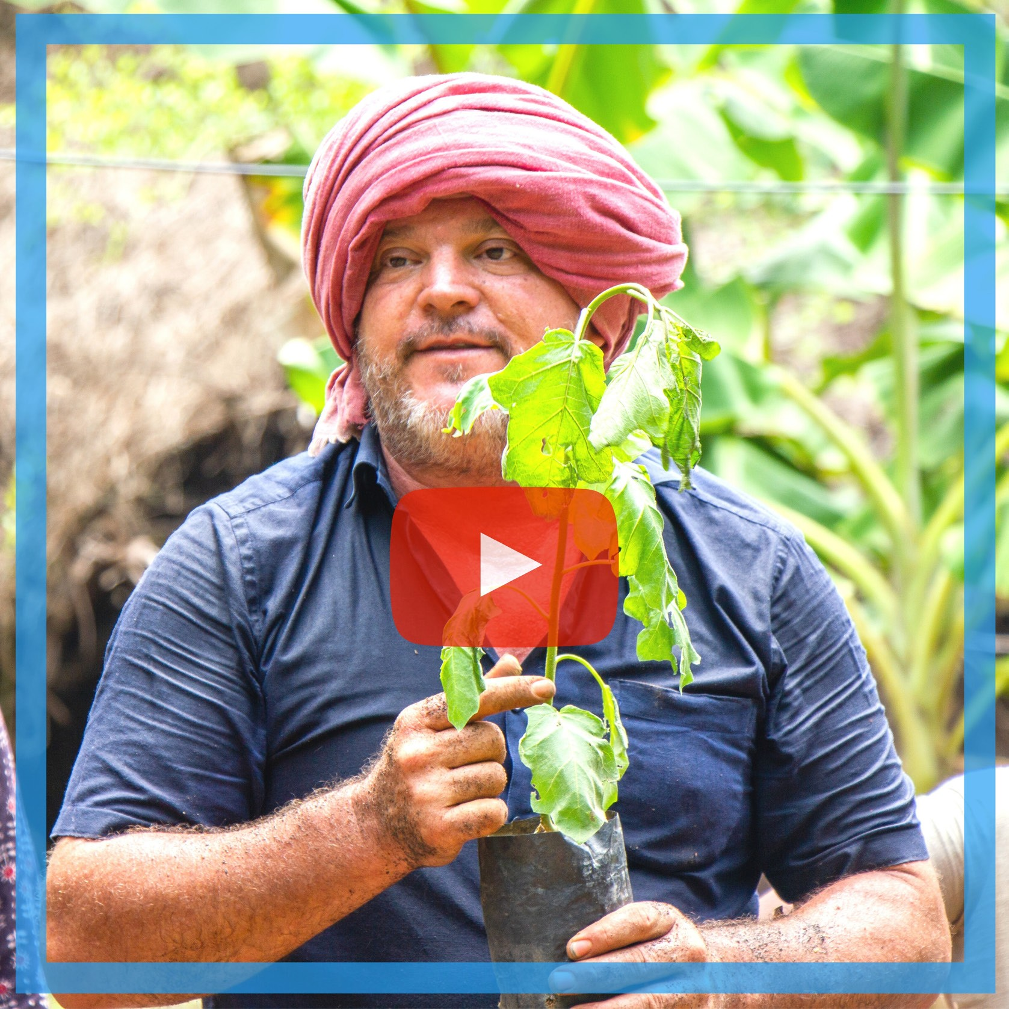There is no dearth of opportunities to create or shift to Fairtrade practices, but the main work will be to find out how to and where to. The distinction will be ne- cessary because some spaces might take longer than others, while some will offer an easy path to turn over a new leaf without damaging the existing ecosystem of functioning.

Adding your own goals!
While on a global and international level all Fairtrade Towns use the set of “5 Core Goals” and India has added two more options to the list, many towns choose to add some of their own to suit their traditions and communities most effectively. The Twin Towns chose to add two extra goals:

- Support local producers and help them to better integrate into the Fairtrade network in India and elsewhere.
- Work on the respect and protection of the environment, as well as, the tangible
and intangible heritage of Pondicherry and Auroville.

The first of these reflect the desire to build both domestic and international sales opportunities for producers via a solidarity economy. All through any of the goals, a common thread with them all is the fact that the Fairtrade Towns project relies heavily on community driven organisation. Everything stems from a social order of support as opposed to having individual markets and goals.

The second aims to preserve the heritage, along with the natural resources, found in abundance in the Twin Towns. Both of the above are intrinsic to the identities of Pondicherry and Auroville. In this manner, the goal will contribute to maintaining and preserving Pondicherry and Auroville’s culture.

This holds not only true for the Twin Towns but for most any town in India. We live in a country rich in culture, tradition and history, and it would remiss to not try and preserve the parts that make the town what it fundamentally is. Therefore, when deciding on your goals, think about parts of the town that are intrinsic to its iden- tity, or even if there are other aspects that you would like to newly introduce, add them as goals to achieve.

Meeting the five goals is a tremendous achievement but being a Fairtrade Town doesn’t stop there. Fairtrade Towns need to keep up the pressure and increase local demand for Fairtrade so more farmers and workers in developing countries can benefit by selling on Fairtrade terms. Once status has been achieved Fairtrade Towns regularly renew their status by submitting updates on progress made on each of the five goals. Renewal applications help Fairtrade Towns maintain mo- mentum and encourage groups to set themselves new targets. Renewal applica- tions mean every community with Fairtrade status continues to support farmers in developing countries by keeping up the call for Fairtrade.

Your Goals!

Applications & Renewals

Applying:

As mentioned in the previous sections, applications and their renewals play a large role in maintaining momentum and Fairtrade status. To make sure that the appli- cation does justice to all your hard work through the journey, maintain a track and record of all your achievements, activities, and media engagements.

When you feel that the requirements have been met, download the applica- tion form from:

Fill out the form with all the details required around the five goals, as well as your
additional ones.

Send the completed application to:

Once the (INSERT WHOEVER IN INDIA YOU SEND IT TO) receives the application, they will confirm the same and ask for any additional information required. The panel will then assess the application and prepare feedback for the group. This feedback will entail which goals have been met adequately, as well as suggestions about ways to further the goal. If the application is successful, you will be awarded a certificate defining your Fairtrade Town identity! If the application is unsuccess- ful, use the feedback and suggestions to develop activity and resubmit the appli- cation when you feel confident the necessary progress has been made.

Renewing:

All Fairtrade Towns must maintain status by submitting a renewal application one year after status is achieved and every two years following that. Make sure pro- gress around the goals is recorded and keep a file (preferably electronic) with de- tails of events, commitments from new organisations, changes in catering and retail outlets and any other information you feel reflects the development of your campaign.

- Download the Fairtrade Towns Renewal Form from:
- Complete with updates on progress made since the last application was sub- mitted and send to:
- The Fairtrade Foundation will assess the renewal application and provide fee- dback with suggestions on how to further develop activity.
- If all the goals are maintained, the next renewal will be due in two years.
- If one or more of the goals is not maintained, the next renewal will be due in one year.

Ill Ill Ill Ill

